Assessment Using Reliability Growth Testing
Result of model comparison (selecting top two models) | 5
Result of range analysis (an explanation of which part of data is good for proceeding with the analysis) | 5
Plots for failure rate and reliability of the SUT for the test data provided | 15
A discussion on decision making given a target failure rate | 10
In this part of the lab, we use the failure data supplied in file Failure Report 3 to assess reliability of SUT with Reliability Growth Testing Analysis in CSFRAT.
After pre-processing and opening the data in CSFRAT, we run an estimation and get several different model results from combinations of chosen hazard function and co-variants. As the effort data (e, f, c) wasn’t supplied we assumed a uniform 1 across the board.
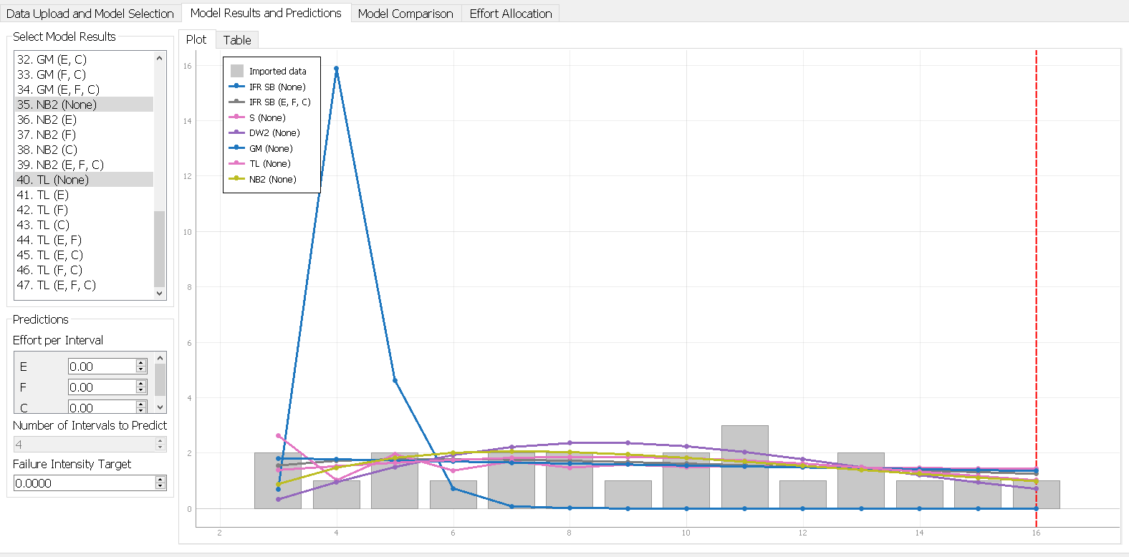
Above is a graph representation of our failures over time .As can be observed above, it is hard to tell exactly which models fit best purely off graphical representation.
Result of model comparison (selecting top two models)
The Model Comparison table below paints a clearer picture of our best models for the data.
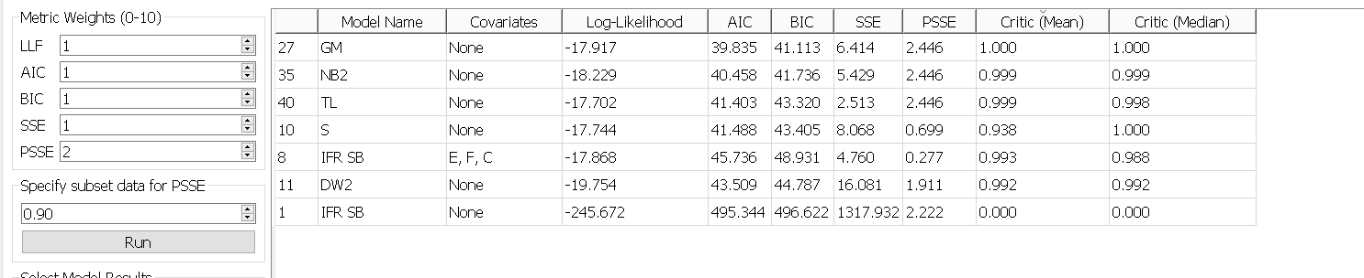

This comparison uses various best fit measures to determine which of the models is statistically the best fit. We use the Critic(Mean), and Critic(Median) as an overall measure of good fit with additional weight assigned to predictive power in PSSE. We find GM(Geometric) to be the best model and NB2(Negative Binomial Order 2) to be second best.
Result of range analysis
For which part of the data is good to analyze, we decided to work from the 3rd interval so 120seconds onward, as there is a big fluctuation in the 60-120 interval which could be attributed to the early-stage testing barrier. From then onward relatively normal fluctuations are observed, and a general decrease in failures is observed over time.

Plots for failure rate and reliability of the SUT for the test data provided
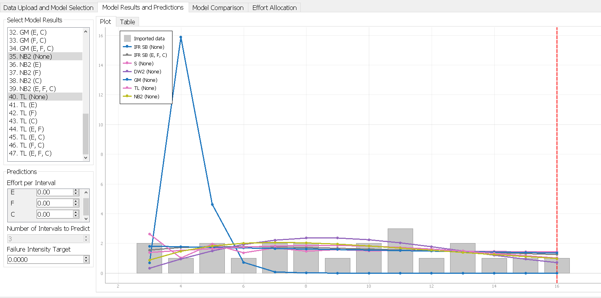
Failure Intensity Plot

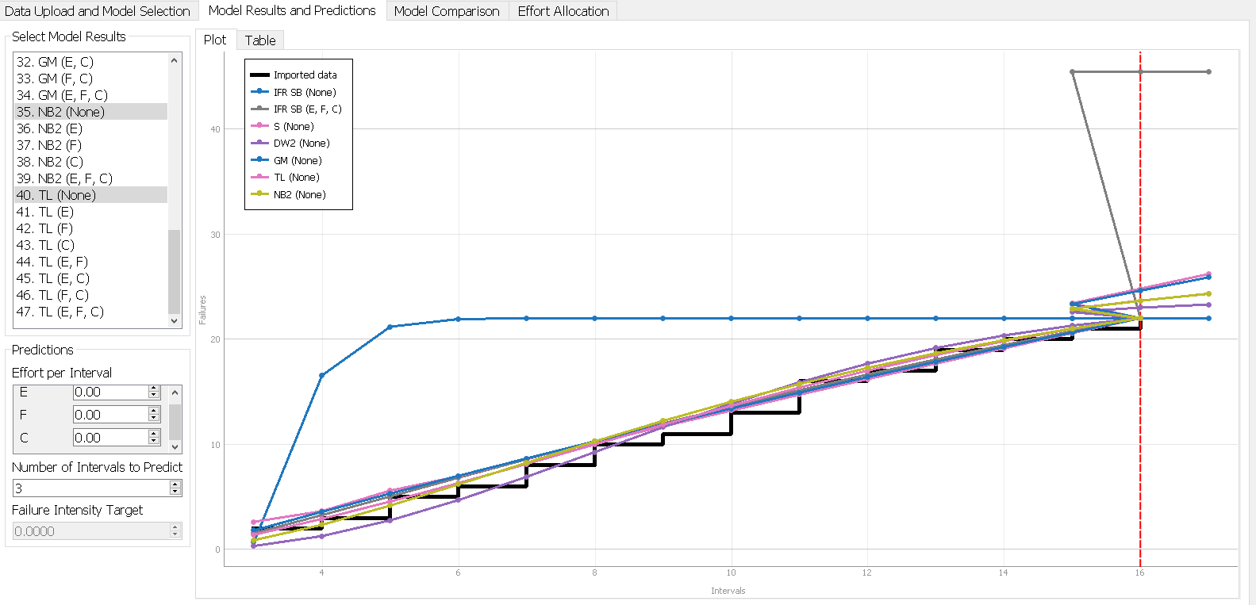
Cumulative Failure Plot
As there is no explicit “reliability” plot in CSFRAT, we simply judge reliability by looking at failures.
A discussion on decision making given a target failure rate
With a known target failure rate, you can use CSFRAT to determine how many intervals it would take to get a failure intensity low enough to meet target. This length of intervals can then be used to estimate time till you can reliably deploy a piece of software.
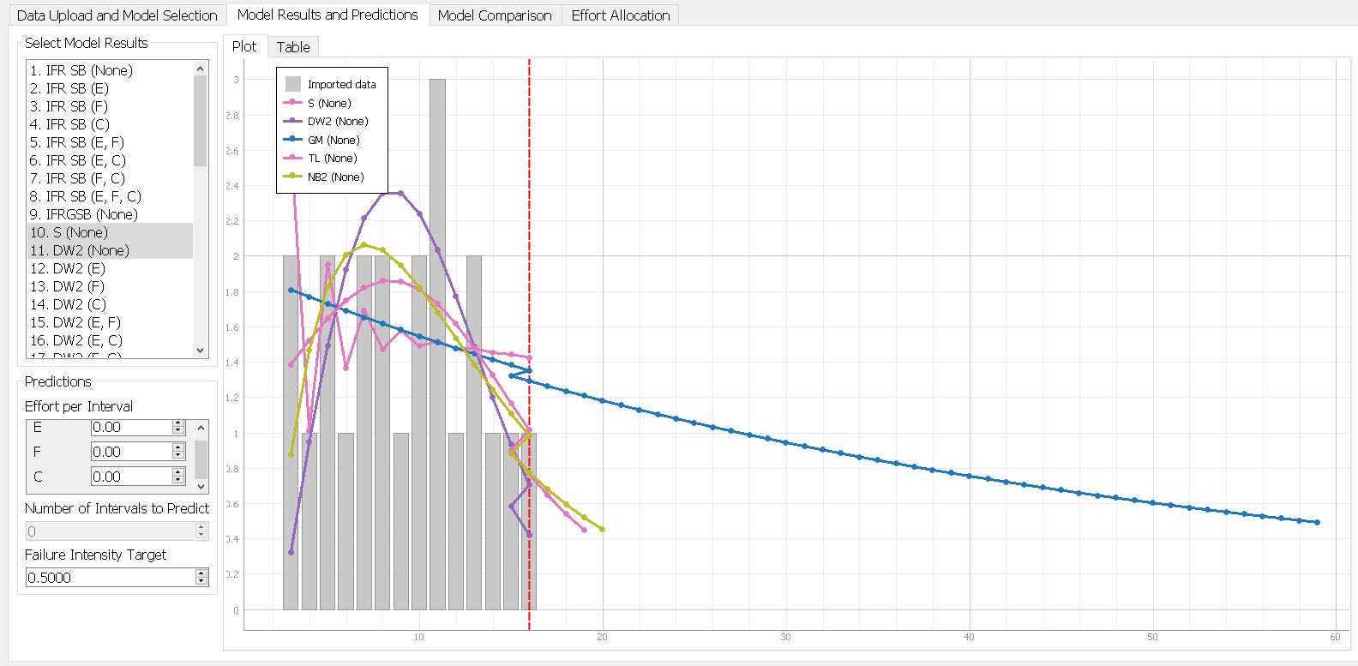
Here we can see that what I judges to be the best model GM will take close to 60 intervals to get a failure intensity down to 0.5 but our next model NB2 predicts 20 intervals to reach target reliability. These significant variations in model predictions play a big role in estimating software reliability growth, and can make a big difference in investment prioritization for software.
A discussion on the advantages and disadvantages of reliability growth analysis
Reliability growth analysis lets you predict how many intervals it would take to ensure a specific degree of reliability in your system. This allows you make sometimes very accurate estimations on time spent fixing issues, and it even allows you to incorporate effort into the model’s predictions. This tool helps planning and estimation in software reliability greatly.
On the flipside, its hard to consistently predict real world phenomena, like bug finding, accurately. No matter the model it can’t guarantee truth, and it is largely dependent on the data it receives. Corruption in the data from incorrect reporting, as well as large variations in failure intensity are harder to model. Lastly, choosing the right model itself does not guarantee you’ve chosen the correct one, as the various measures are only so correct.

